L21: Preparation Assignment Worked Solutions 221 B&C
Part I: Concepts
- Describe role of the correlation coefficient. What does it measure? What are its bounds?
The correlation coefficient is used to measure the direction and strength of the linear association between two variables. The direction can either be positive, negative, or neither, and the strength can be described as weak, moderate, or strong. It is always between -1 and 1 inclusive.
- Sketch a graph of 10 $(x,y)$ coordinates on an $x-y$ plane where the data have a strong linear positive correlation.
Students should have a graph sketched here. Here is an example graph. You may either sketch by hand or you can click on Insert – Chart – XY Scatter here in Word to make one similar to the one below.

Part II: Application To answer the following questions, use the Gharial Crocodiles Data.

- The Correlation Coefficient between Head Length and Body Length of the Gharial Crocodiles is:

r = 0.986

To find the correlation coefficient in SPSS, open the Gharial Crocodile data and perform the following SPSS commands. Analyze – Correlate – Bivariate. Move both Variables over into the “Variables” list at the right. Click on the options tab and make sure the Means and Standard Deviations box is checked. This will help you on the next problem. Then click on OK. The correlation coefficient will be labeled as “Pearson Correlation”. Math the row and column of the variables you want to compare. It will look like the following.

Correlations
 |  | Head Length (cm) | Body Length (cm)
Head Length (cm) | Pearson Correlation | 1 | .986**
Head Length (cm) | Sig. (2-tailed) |  | .000
Head Length (cm) | N | 17 | 17
Body Length (cm) | Pearson Correlation | .986** | 1
Body Length (cm) | Sig. (2-tailed) | .000
Body Length (cm) | N | 17 | 17
**. Correlation is significant at the 0.01 level (2-tailed).

- The Covariance of the Head Length and the Body Length of the Gharial Crocodiles is:

Covariance = $r\left(s_{x}\right)\left(s_{y}\right)=$0.986(108.078)14.397 = 1534.215

The standard deviations were given in the other table of the output we did for the previous question.

Descriptive Statistics
 | Mean | Std. Deviation | N
Head Length (cm) | 50.45 | 14.397 | 17
Body Length (cm) | 303.94 | 108.078 | 17

- Create a scatter plot representing the relationship between Head Length and Body Length of the Gharial Crocodiles. Paste your scatter plot below:

To make a scatterplot in SPSS do the following. Graphs – Legacy Dialogs – Scatter/Dot, then click on Define. Move the response variable into the “Y-axis” box, or in this case the body length. Move the explanatory variable into the “X-axis” box or in this case the head length. Click on OK. The scatterplot should look like the following.

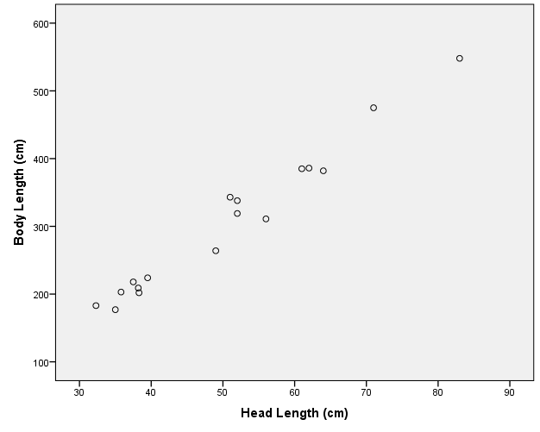

- Discuss the relationship you see in the scatter plot between the two sets of bivariate data for the Gharial Crocodile.

There is a strong positive linear relationship between the head length and body length of the Gharial Crocodile. We can say this because the data points are going in a positive direction and they are all close around a line.

